**Cursors – CO2.2**

1.Calculate Interest for Fixed Deposit Amount Using Cursors.

set intrest as 0 and then update it using the program.

set 10% intrest for amount less than or equal to 1000.

20% for more then 1000 to 5000.

30% for above 5000.

**Program**

create table deposit(accno int primary key,year int,amount int,interest int);

insert into deposit values(&accno,'&year',&amount,&interest);

declare

cursor c1 is select * from deposit;

begin

for i in c1

loop

if i.amount<=1000

then

update deposit set interest=i.amount*0.1 where accno=i.accno;

elsif i.amount>1000 and i.amount<=5000

then

update deposit set interest=i.amount*0.2 where accno=i.accno;

else

update deposit set interest=i.amount*0.3 where accno=i.accno;

end if;

end loop;

end;

**Output**

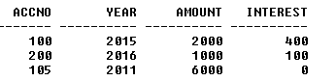

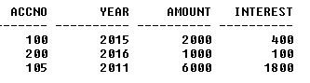

2. Calculate Electricity Bill Using Cursors.

**Program**

create table bill(ebno number(20) primary key, name varchar(20), eunit number(20), echarge float);

insert into bill values(&eb,'&name',&eunit,&echarge);

declare

cursor cbill is select * from bill;

begin

for i in cbill

loop

if i.eunit<100 then

update bill set echarge =i.eunit*0.1 where ebno=i.ebno;

elsif i.eunit>=100 and i.eunit<=200 then

update bill set echarge=i.eunit*0.2 where ebno=i.ebno;

else

update bill set echarge=i.eunit*0.3 where ebno=i.ebno;

end if;

end loop;

end;

/

**Output**

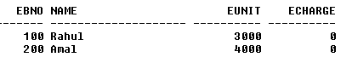

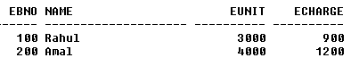

3. Write PL/SQL code to UPDATE values in created tables by using Implicit Cursors.

**Program**

Create table dhemp(id number(20),ename varchar(20),esalary number(20));

Insert into dhemp values(&id,’&ename’,&esalary);

declare

rowno number(20);

begin

update dhemp set salary=esalary+200;

if sql%notfound then

dbms_output.put_line(‘No salary updated’);

else if sql%found then

rowno:=sql&rowcount;

dbms_output.put_line(‘Salary for’||rowno||’employees updated’);

end if;

end;

/

**Output**

4. Given the table works(emp_id,company_name,salary),write a cursor to select the three highest paid employees from the table.

**Program**

**Output**